|  |  |  |  |  |  |
| --- | --- | --- | --- | --- | --- |
| Date | 6-Dec-22 | | | Tester Name | Janette Paus |
| Environment | Penfax - Test 2 | | | Login used | <If different from the Tester> |
| Operating System | Windows | Version: 21H2 | Update Number: | | |
| Software Used | Select Software | Version: 107.0.1418.56 | Update Number: | | |
| Select Software | Version: | Update Number: | | |
| Application Release version | R22.4.1 | | | | |
| Test Case Title | E20.13 | | | | |
| Test Type | Regression | | | | |
| Test Scenario | Create Accounts Payable | | | | |
| Expected Results | That a cheque or EFT will be generated to return funds to the employer as per the amount entered when completing the payable. | | | | |
| Pass/Fail | Pass | | | JIRA# |  |

Go to Accounting 🡪 Accounts Payable 🡪 Add Payable

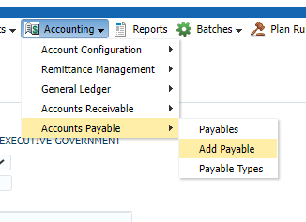

Enter Plan, Payable Type, Any amount, Date

Plan = PEPP; Stakeholder ID = 437869; Payable Type = Employer Over-Contribution; Payable Amount= $$$; Payable Date = Dec 6, 2022. Click Save

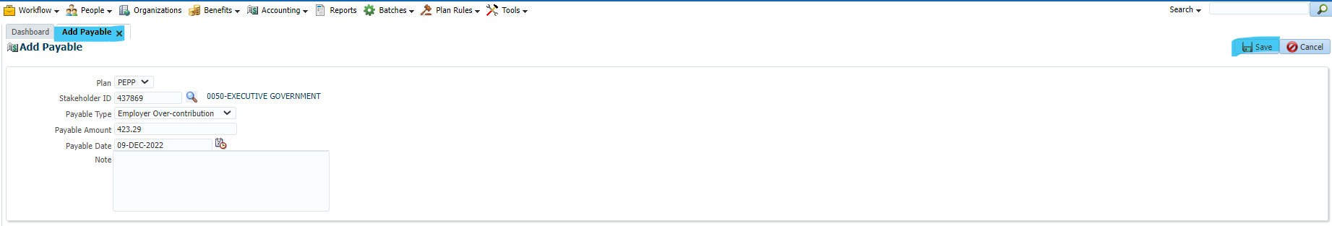

Then click Approve

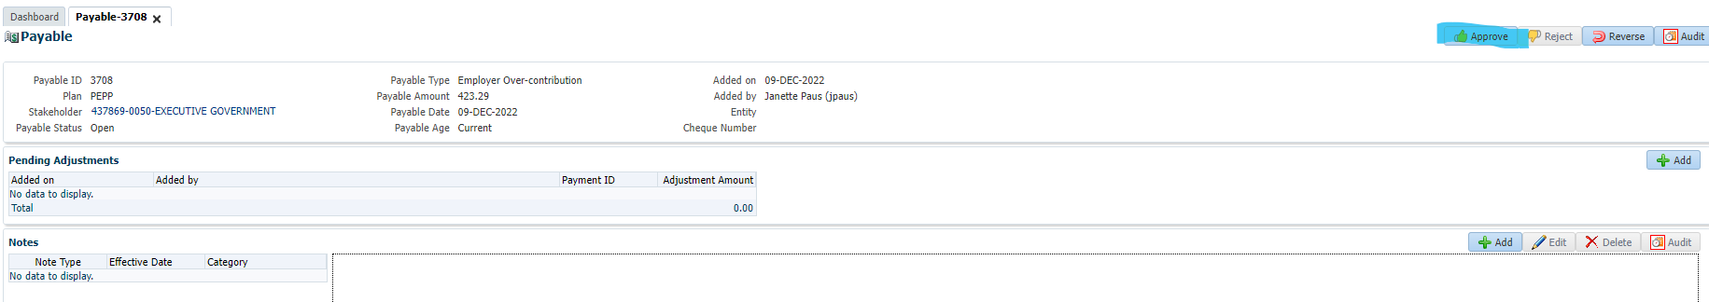

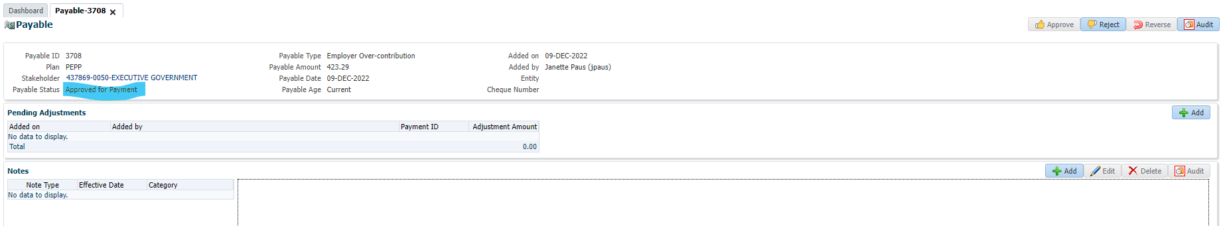

Next Day

Open Accounting 🡪 Payables, search for Stakeholder ID used in the payable added day before

Status of payable should show cleared and cheque number should be assigned

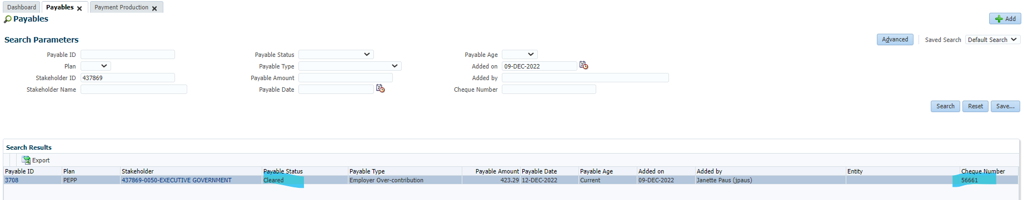

Go to Accounting 🡪 General Ledger

Search Plan = PEPP; Journal Entry Date = Date of Payable; Stakeholder ID used in the Payable and click Search

The Transaction Types Create Payable and Clear Payable for the payment amounts (both for Debits and Credits) should be populated in the search results.

